**Leader-Follower Robots**

**Abstract**

Problem Statement (Basic):

The Slave robot has to trace the path traversed by a Master robot. The master robot is either externally controlled or tracks a line.

Problem Statement (Advanced):

Localize using odometer readings from Master Robot and the Slave robot has to move to that location.

Requirements:

* 1 no - Arduino
* 1 no - Raspberry Pi
* 1 or 2 no - HC-05 Module
* 3 no – Zigbee Modules
* 1 no - IR Array (optional)
* 4 no - DC Motors with encoders
* 2 no - DC Motor Drivers
* 2 no - Chassis

Fabrication:

The Leader robot is assembled with Arduino with HC-05 and the other with Raspberry Pi. Both the bots are fitted with dc motors with encoders and connected to the motor drivers. The bots are then paired to each other via Bluetooth.

Algorithm:

Basic:

The Leader robot is controlled to move in a specific path as directed by a mobile via Bluetooth or the bot is made to track a given line using IR Array.

The encoder values are recorded to get the angle and velocity of each of the motors and are sent to the follower robot at regular intervals.

With the data received from the leader robot, the slave robot travels in the same path as traversed by the leader bot with the encoder feedback.

Advanced:

The Leader robot is made to travel in a hardcoded path or externally controlled path.

The encoder values are recorded and the velocity of each wheel and the angle made by the bot are calculated from the known values of R - radius of wheel and L - track of the bot.

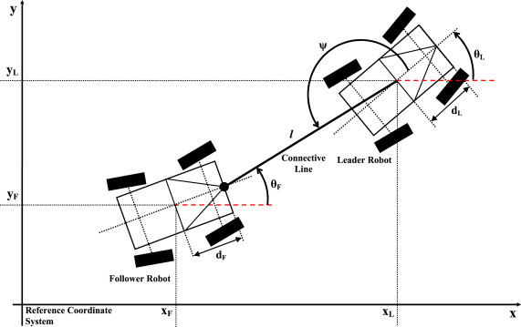

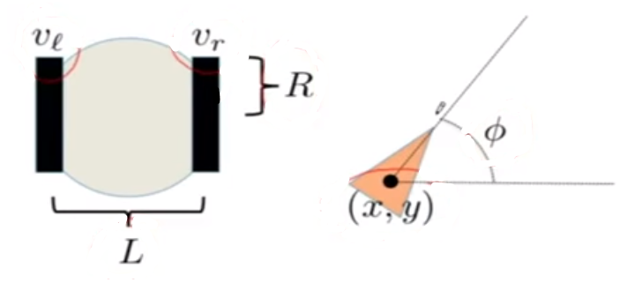

Encoder:

Distance per click, C = $\frac{2πR}{H}$, (H – No. of clicks)

Distance travelled by right wheel, $D_{r}=C_{r}H_{r}$

Similarly for left wheel, $D_{l}=C_{l}H_{l}$

Distance moved by the bot (centre of axle), $∆S=\frac{D_{r}+D_{l}}{2}$

Velocity of bot – v

$\dot{∅}=ω=\frac{R}{L}\left(v_{R}-v_{c}\right)$ And $∅=\frac{D_{r}-D_{l}}{L}$

$\dot{x}=v\cos{∅}=\frac{R}{2}(v_{r}+v_{l})cos{∅}$ And $x=∆S cos{∅}$

$\dot{y}=v\sin{∅}=\frac{R}{2}(v_{r}+v_{l})sin{∅}$ And $y=∆S sin{∅}$

The values are calculated at regular intervals and are updated to ‘x’ and ‘y’ coordinates of the leader bot and sent to the follower for it to know the location of the leader while keeping track of its position.

So, by knowing the distance in x and y directions and its present angle, the follower calculates the angle to be turned and the distance to be covered. The follower moves behind the leader robot using PID to adjust the distance and speed.